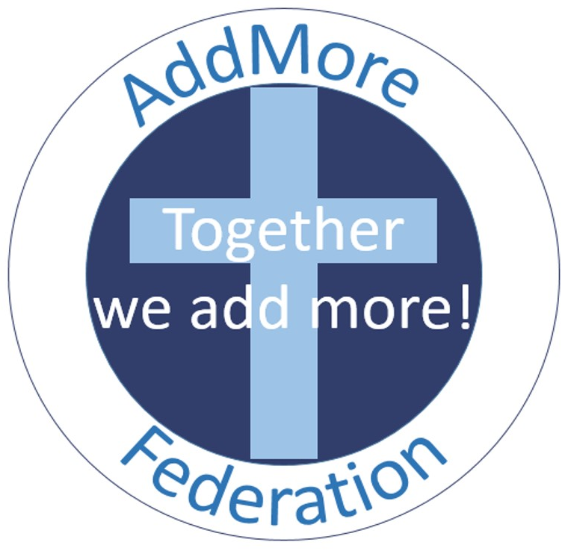
POLICY CONTROL
GEOGRAPHY POLICY
Responsible Governor Committee: | Standards and Curriculum
Approved by Governors: | Summer 2022
Review Date: | Summer 2025

‘Love your neighbour as yourself’
Parable of the Good Samaritan Luke 10:25-37

Our school policies are written with the objective of realising our vision:

As we journey together. we learn to live as good neighbours, demonstrating love, compassion, dignity and respect to all in our communities.
Through this we aspire to become global citizens, courageous advocates and people of wisdom and integrity.
We look towards the parable of the Good Samaritan as our guide.
A school where all children are valued, where they feel safe, are happy and learn well. We want our school to have a warm friendly atmosphere, which supports families, builds relationships and sets children up for a life of learning. We want our Christian values to guide our pupils along the right path and help them to achieve fulfilling and happy lives.

OUR SCHOOL VALUES
Adderley and Moreton Say Church of England Primary Schools values:
Respect □ Hopefulness □ Kindness □ Courage □ Integrity □ Curiosity

- AIMS
  - The aim of geography teaching in the AddMore Federation is to stimulate the children’s interest and understanding about the world and its people. ‘ Teaching should equip pupils with knowledge about diverse places, people, resources and natural and human environments, together with a deep understanding of the Earth’s key physical and human processes.’ National Curriculum 2014.

  - The aims of geography in our federation are:
- To foster in children an interest in the world and its people and to develop an understanding that enables them to enjoy all that geography has to offer;
- To enable children to know about significant global places;
- To understand the processes related to physical and human geography;;
- To develop children’s skills of enquiry, data collection and interpretation, investigation, analysis, evaluation and presentation.

- TEACHING AND LEARNING
  - Geography focuses on enabling children to think as geographers. In the teaching and learning of geography we can identify a number of objectives for the children:
- To develop an awareness of the nature and use of evidence. Children have the opportunity to use primary and secondary sources;
- To build up knowledge of location and place;
- To identify features of human and physical geography and understand the interdependence of the processes related to these;
- To develop and use correctly geographical vocabulary and technical terms;
- To encourage children to interpret, explain and ask geographical questions. For example: Why is this the case? How do we know this is true?
- To develop a range of geographical skills to help them understand and interpret the world around them.

  - We recognise that in all classes, there are children of different abilities and we seek to provide suitable learning opportunities for all children by matching the challenge of the task to the ability of the child. We achieve this by:
- Setting common tasks which are open ended and can have a variety of responses;
- Setting tasks of increasing difficulty. Not all children complete all tasks;
- Grouping children by ability in the room and setting different tasks for each ability group;
- Using mixed ability grouping when completing some tasks;
- Providing resource of different complexity depending on the ability of the child;
- Wherever possible, using teaching assistants to support children individually or in groups.

- PLANNING: Foundation Stage
  - We teach geography in the Foundation Stage as an integral part of the topic work covered during the year. In our Early Years settings geography is taught as part of the Foundation Stage curriculum: Understanding the World. This is one of the seven areas of learning in the Foundation Stage.
  - Geography is taught through practical and play tasks that may include visits to a variety of different locations, role paly and dressing up, handling objects and looking at photos and other sources of evidence.

  - Themes are loosely planned across the year but space is given for planning to follow children’s own interests. Pupils will consider the meaning of place, weather patterns and other geographical features in relation to their own lives and in relation to themes that they may have initiated.

- PLANNING: Key Stage 1 and Key Stage 2
  - Throughout Key Stage 1 and Key Stage 2 Geography is taught through topic work. Children of all abilities have the opportunity to develop their skills and knowledge in each unit of work and we offer them increasing challenge as they move through the school.

  - The National Curriculum defines what must be taught in Geography at each Key Stage and this forms the basis for our curriculum planning. Our topic themes are based on a two year rolling programme for Key Stage 1 and a four year rolling programme for Key Stage 2.

  - We use news and current affairs as themes to motivate and interest pupils where possible. E.g. the Queen’s Jubilee; World War commemorations, sporting competitions etc.

- EQUAL OPPORTUNITIES
  - AddMore Federation promotes equal opportunities and does not discriminate against any individual on the grounds of race, gender, age, disability or beliefs. Where necessary, adaptations will be made to the curriculum, to equipment and to resources to allow equal opportunities for all.

- SEN
  - Planning ensures SEN pupils are fully included in all geography lessons. We make necessary provisions so that every child can access the geography curriculum by: differentiating work and questioning; providing additional adult support where necessary; and using specific resources and equipment.

- RESOURCES
  - Project loans from the Shropshire Library Service are used to provide extra published and audio-visual resources for topic work. Interactive Boards are used to assist learning, through the use of visual and audio aids such as slide shows and video clips. Each class has a suite of laptops that are internet ready and which are used for research and reference. Educational visits are planned to support the geography curriculum.

- ASSESSMENT
  - Pupils’ work is assessed formally at the end of the year. Pupils are awarded either Working Towards the expected level; Working At the expected level or Working Above the expected level.

